34.4: a) 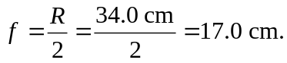
b) If the spherical mirror is immersed in water, its focal length is unchanged—it just depends upon the physical geometry of the mirror.

